**Laboratory Exercise 14.1- Using an Object Table of XMLType in Oracle**

1. Create an Oracle Object Table consisting of an XMLType object, as shown in Figure 14.19(a), calling the table Employees.

**CREATE TABLE Employees of XMLTYPE;**

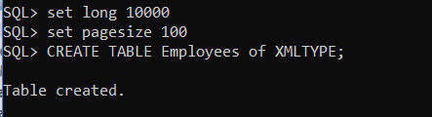

Figure 1

2. Insert three records into the table using XML format similar to that shown in Figure 14.19(b). Include empid, name, address, phone, job title, salary, and any other data items you wish.

**INSERT INTO Employees VALUES(XMLTYPE(**

**'<EMPLOYEE TYPE="Full-Time" STATUS="Active">**

**<EMPID>1</EMPID>**

**<NAME>**

**<FIRSTNAME>John</FIRSTNAME>**

**<LASTNAME>Smith</LASTNAME>**

**</NAME>**

**<ADDRESS>**

**<STREET>10 Main Street</STREET>**

**<CITY>New York</CITY>**

**<STATE>NY</STATE>**

**<ZIP>10001</ZIP>**

**</ADDRESS>**

**<PHONE>**

**<AREACODE>212</AREACODE>**

**<PHONE_NUMBER>1234567</PHONE_NUMBER>**

**</PHONE>**

**<JOB_TITLE>Software Engineer</JOB_TITLE>**

**<SALARY>90000</SALARY>**

**</EMPLOYEE>'));**

**INSERT INTO Employees VALUES(XMLTYPE(**

**'<EMPLOYEE TYPE="Full-Time" STATUS="Active">**

**<EMPID>2</EMPID>**

**<NAME>**

**<FIRSTNAME>Bob</FIRSTNAME>**

**<LASTNAME>Carter</LASTNAME>**

**</NAME>**

**<ADDRESS>**

**<STREET>250 Summer Street</STREET>**

**<CITY>White Plains</CITY>**

**<STATE>NY</STATE>**

**<ZIP>10601</ZIP>**

**</ADDRESS>**

**<PHONE>**

**<AREACODE>914</AREACODE>**

**<PHONE_NUMBER>9876543</PHONE_NUMBER>**

**</PHONE>**

**<JOB_TITLE>Recruiter</JOB_TITLE>**

**<SALARY>60000</SALARY>**

**</EMPLOYEE>'));**

**INSERT INTO Employees VALUES(XMLTYPE(**

**'<EMPLOYEE TYPE="Full-Time" STATUS="Active">**

**<EMPID>3</EMPID>**

**<NAME>**

**<FIRSTNAME>Sara</FIRSTNAME>**

**<LASTNAME>Lee</LASTNAME>**

**</NAME>**

**<ADDRESS>**

**<STREET>987 Rose Street</STREET>**

**<CITY>Stamford</CITY>**

**<STATE>CT</STATE>**

**<ZIP>06905</ZIP>**

**</ADDRESS>**

**<PHONE>**

**<AREACODE>203</AREACODE>**

**<PHONE_NUMBER>6549872</PHONE_NUMBER>**

**</PHONE>**

**<JOB_TITLE>Manager</JOB_TITLE>**

**<SALARY>120000</SALARY>**

**</EMPLOYEE>'));**

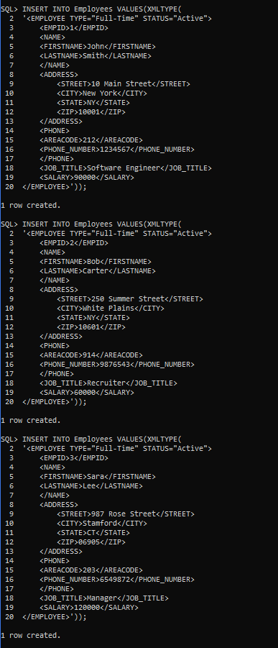

Figure 2

3. Make up five queries using Figure 14.19(c)-(g) as models.

Query 1:

**SELECT object_value FROM Employees;**

Query 2:

**SELECT EXTRACT(object_value, '/EMPLOYEE/NAME') FROM Employees;**

Query 3:

**SELECT**

**EXTRACTVALUE(object_value, '/EMPLOYEE/NAME/FIRSTNAME'),**

**EXTRACTVALUE(object_value, '/EMPLOYEE/NAME/LASTNAME'),**

**EXTRACTVALUE(object_value, '/EMPLOYEE/ADDRESS/CITY'),**

**EXTRACTVALUE(object_value, '/EMPLOYEE/ADDRESS/STATE')**

**FROM Employees;**

Query 4:

**SELECT**

**EXTRACTVALUE(object_value, '/EMPLOYEE/NAME/FIRSTNAME'),**

**EXTRACTVALUE(object_value, '/EMPLOYEE/NAME/LASTNAME'),**

**EXTRACTVALUE(object_value, '/EMPLOYEE/JOB_TITLE'),**

**EXTRACTVALUE(object_value, '/EMPLOYEE/SALARY')**

**FROM Employees**

**WHERE EXTRACTVALUE(object_value, '/EMPLOYEE/SALARY') > 90000;**

Query 5:

**SELECT**

**EXTRACTVALUE(object_value, '/EMPLOYEE/JOB_TITLE'),**

**EXTRACTVALUE(object_value, '/EMPLOYEE/SALARY')**

**FROM Employees**

**WHERE EXTRACTVALUE(object_value, '/EMPLOYEE/NAME/FIRSTNAME') = 'John';**

4. Execute the five queries in the database and show the results.

Note: To display all of the data properly, run the following 2 statements after you login to the Oracle Database (before running the five queries):

SET LONG 10000

SET PAGESIZE 100

**Query 1:**

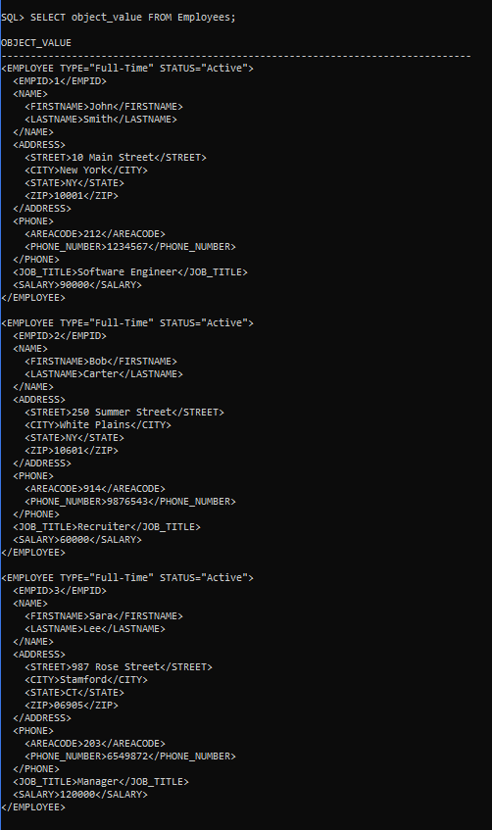

Figure 3

**Query 2:**

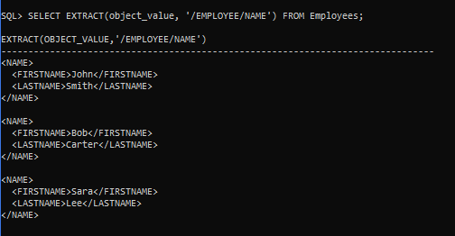

Figure 4

**Query 3:**

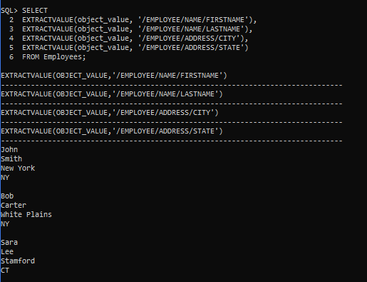

Figure 5

**Query 4:**

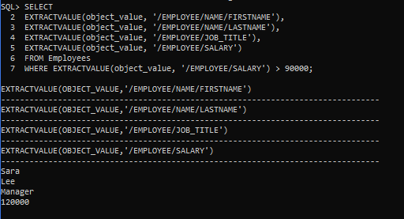

Figure 6

**Query 5:**

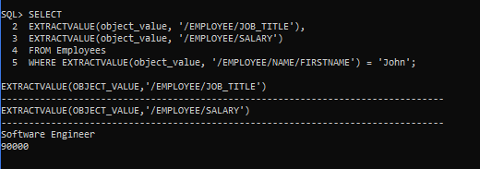

Figure 7